VI. System Model

Overall Hubbub Use Case Diagram

The Following diagram provides incite into the entire Hubbub system and usage.

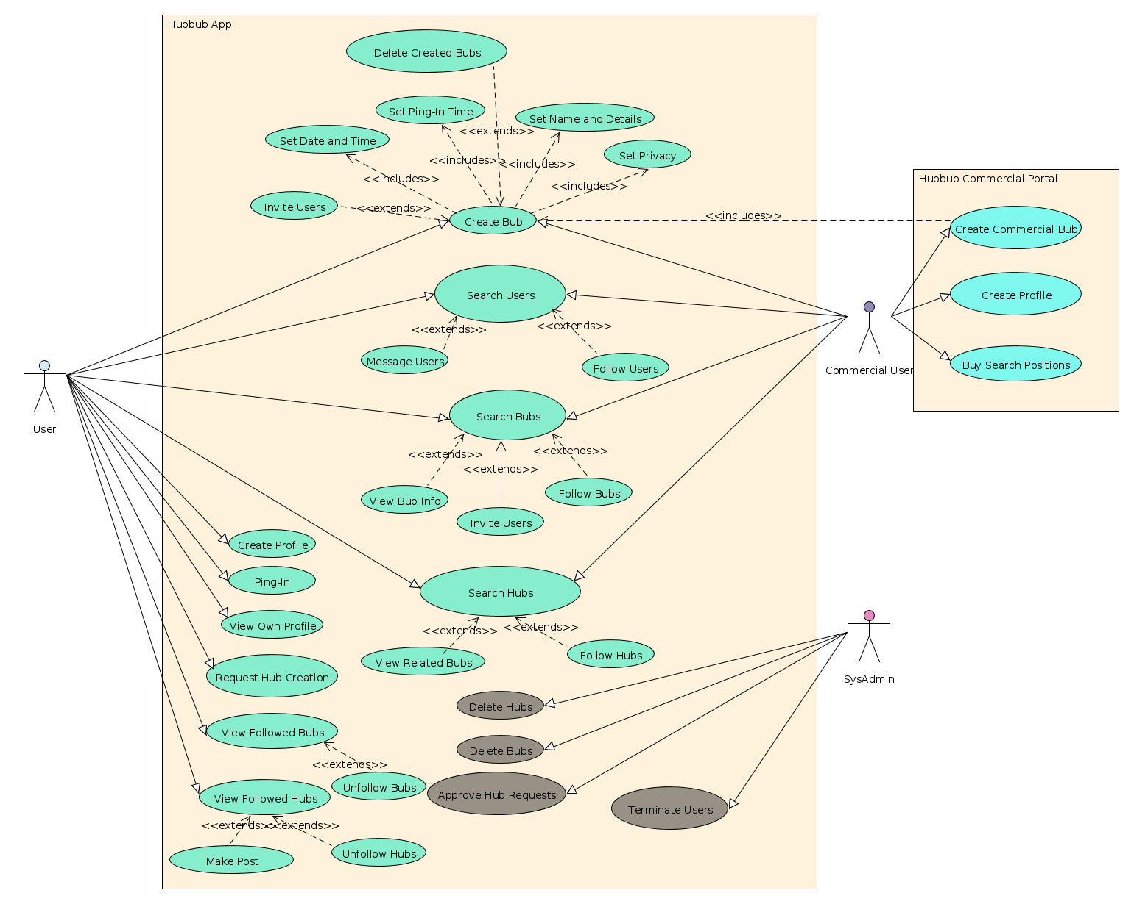

Brief System Overview

The following is a generic example of the application navigation and work flow.

User:
1) A User can create an account with Hubbub inputting important information such as
name, date of birth, email, etc. Alternatively, users can login using other social networking accounts already established.
2) Users can then login and view the main User UI. Lists of Hubs followed (Defaults will be set), Featured or today's Bubs, Followed Bubs, etc.
3) Users at will can create or search for Bubs. When creating, they can invite those followed, set certain times for the event and ping-in, set detail information in regards to the bub, etc.
4) Users at will can search for Hubs. Bubs tagged with the Hub's name will be listed in the Hub's Bub page. Users can follow both the Bub and or the Hub they've searched for respectively.
5) Users at will can search for specific Bubs by Hub tag, name, or time. Users can follow Bub and navigate to the corresponding Hub's tagged within the Bub if wishing to search for similar Bubs in nature or topic.
6) After following Bubs, users will be forced to ping-in at the Bub's respective ping-in times. They will make a decision and their attendance status will be recorded.
7) Users periodically will be information by push notifications of posts in either hubs or bubs they've created or followed.
8) A User session is persistent and can remain running in the background. Refreshing the UI and real-time updating Hub and Bub information will be available as the application is running.
9) However, a user may log out and shutdown the app at any moment. The only persistence afterwards will be the ability and event of a ping-in. Users will be required to ping-in event if the application is not currently in the foreground.

Commercial Users:
1) Commercial Users will have their own login and will have similar abilities to a user with some additional functionality.
2) After creating an account, user privileges will be administered with the addition of creating commercial Bubs. These Bubs will have a verified location and will have the ability to be charged for higher listings when searched under certain tags.
3) Commercial Users can choose certain tags for higher listings and will be charged accordingly for such abilities.
4) After creating events, Commercial Users will then be able to view their events and follow others as well. Navigation through the Hubbub application can occur over the android application and the addition Commercial User options will be accessible at any time.

System Admin:
1) SysAdmin's will be able to login through the app as do regular users. Afterwards, they will have full control over Hub's existence and Bub presentation.
2) At any time, SysAdmin's can modify User existence, Bub existence, and Hub existence if exploitation is to occur.

Use Case Descriptions

The following use cases will be the core of the Hubbub application and will be further explored below:
- Create User
- Create Commercial User
- Create Bub
- Request Hub
- Search Bub
- Search Hub
- Search User
- Ping-In
- Make Post
- View Followed Bubs
- View Followed Hubs
- Invite Users

Create User:
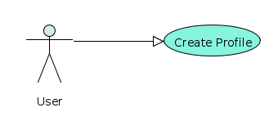

Description:
Users will input information and submit it to the database to create a profile to view Hubs and Bubs. After the creation, Users will use the profile to login and use Hubbub as a whole.
Steps:
- Navigate to main application page
- Type in Name, Username, Email, Password, Date Of Birth, About me, etc.
- Check for errors and tap submit button
- Tap Confirm on information check prompt
- Receive Server Confirmation notification

Create Commercial User:
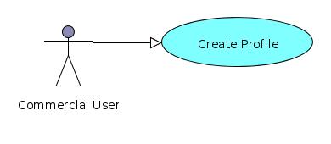

Description:
Commercial Users will input information similar to users only they will need provide proof of commercial ownership for such business or institution.
Steps:
- Navigate to main application page
- Type in Name, Username, Email, Password, Date Of Birth, About me, etc.
- Provide Photocopy of addressed mail or certificate of ownership and confirm company listed email address
- Check for errors and tap submit button
- Tap Confirm on information check prompt
- Receive Server Confirmation notification

Create Bub:

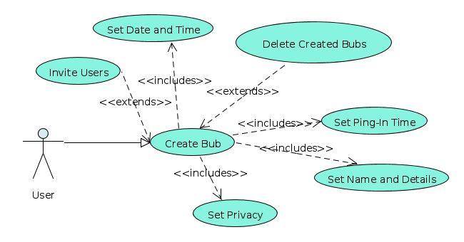

Description:
Users can at will create a Bub at any time. Some information will be required for creation, such as Name, Date and Time, Ping-In Time, at least one tag, and Privacy. Other information including details, what to bring, and invited users is considered optional at time of creation. After confirming information, users Bub will be listed under the Hub corresponding to the tag.
Steps:
- Tap the plus sign in the menu bar
- Enter information required for the event
  - Name, Date and Time's, Ping-in, one Tag, and Privacy
- Enter option information including details, invited users, etc.
- Tap Create Event and fix any listed errors, such as missing information
- Notification of creation will be displayed if success

Request Hub:
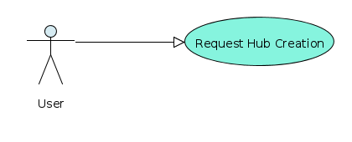

Description:
If a specific hub does not exist for a given topic, idea, or object of interest, a user can request the hub be created at will. Hub requests will be approved by SysAdmin's and if the approval is accepted, any users who have requested the hub be created will be notified upon creation or denial. Hub requests will be filtered by bad language, explicit content, ect. as such the reason for requests exists.
Steps:
- Visit the search Hub's page
- If a failed hub search is returned, a button to create the Hub request will be provided
- Provide the Hub name that will be used when tagging Events. Hub names could be anything from a band name to a common hobby but must be relatively appropriate for the majority of people.
- Enter a description with added information, hyper links, or anything that will help establish the tag as a legitimate and commonly appreciated Hub of interest
- Tap Submit Hub Request button and verify requested Hub name
- Receive request admittance notification

___________________ LINE OF COMPLETION_________________________
___________________ LINE OF COMPLETION_________________________
___________________ LINE OF COMPLETION_________________________
___________________ LINE OF COMPLETION_________________________

Search Bub:
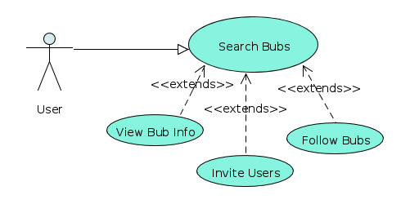
Description:
Users will input information and submit it to the database to create a profile to view Hubs and Bubs. After the creation, Users will use the profile to login and use Hubbub as a whole.
Steps:
- Navigate to main application page
- Type in Name, Username, Email, Password, Date Of Birth, About me, etc.
- Check for errors and tap submit button
- Tap Confirm on information check prompt
- Receive Server Confirmation notification

Search Hub:
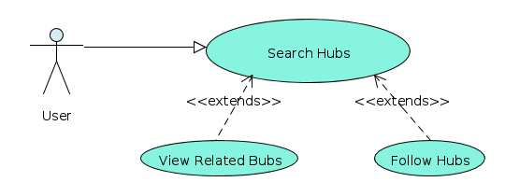
Description:
Users will input information and submit it to the database to create a profile to view Hubs and Bubs. After the creation, Users will use the profile to login and use Hubbub as a whole.
Steps:
1) Navigate to main application page
2) Type in Name, Username, Email, Password, Date Of Birth, About me, etc.
3) Check for errors and tap submit button
4) Tap Confirm on information check prompt
5) Receive Server Confirmation notification

Search User:
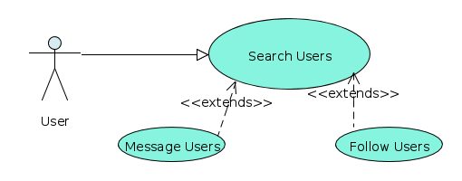
Description:
Users will input information and submit it to the database to create a profile to view Hubs and Bubs. After the creation, Users will use the profile to login and use Hubbub as a whole.
Steps:
1) Navigate to main application page
2) Type in Name, Username, Email, Password, Date Of Birth, About me, etc.
3) Check for errors and tap submit button
4) Tap Confirm on information check prompt
5) Receive Server Confirmation notification

Ping-In:
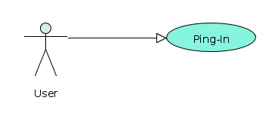

Description:
Users will input information and submit it to the database to create a profile to view Hubs and Bubs. After the creation, Users will use the profile to login and use Hubbub as a whole.
Steps:
1) Navigate to main application page
2) Type in Name, Username, Email, Password, Date Of Birth, About me, etc.
3) Check for errors and tap submit button
4) Tap Confirm on information check prompt
5) Receive Server Confirmation notification

Make Post:
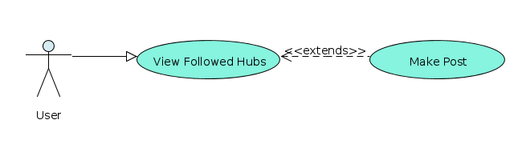
Description:
Users will input information and submit it to the database to create a profile to view Hubs and Bubs. After the creation, Users will use the profile to login and use Hubbub as a whole.
Steps:
1) Navigate to main application page
2) Type in Name, Username, Email, Password, Date Of Birth, About me, etc.
3) Check for errors and tap submit button
4) Tap Confirm on information check prompt
5) Receive Server Confirmation notification
View Followed Bubs:
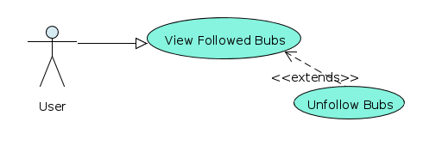
Description:
Users will input information and submit it to the database to create a profile to view Hubs and Bubs. After the creation, Users will use the profile to login and use Hubbub as a whole.
Steps:
1) Navigate to main application page
2) Type in Name, Username, Email, Password, Date Of Birth, About me, etc.
3) Check for errors and tap submit button
4) Tap Confirm on information check prompt
5) Receive Server Confirmation notification
View Followed Hubs:
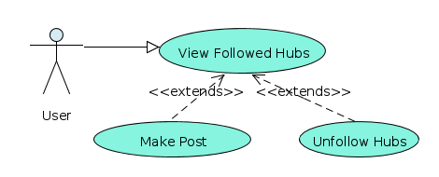

Invite Users:

